IMPLEMENTATION OF CONVOLUTIONAL NEURAL NETWORKS (CNNs) FOR IMAGE CLASSIFICATION

Dataset Preparation:
Sample images after resizing:
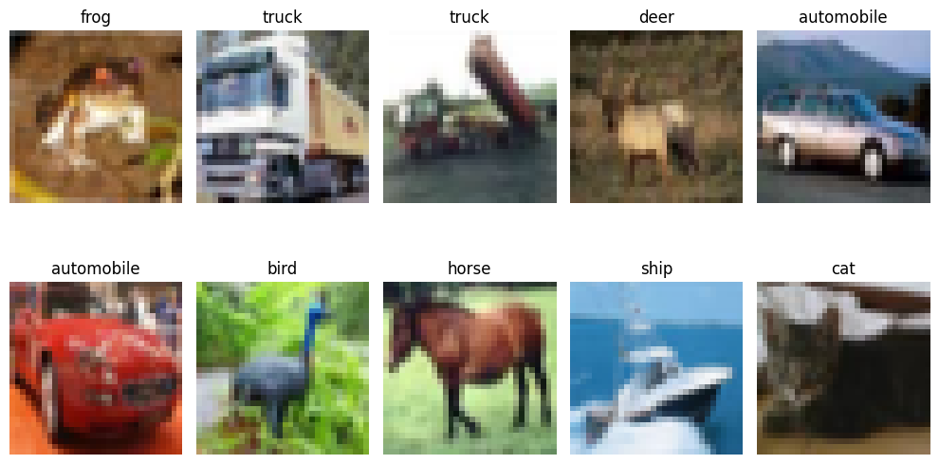
Images after processing:
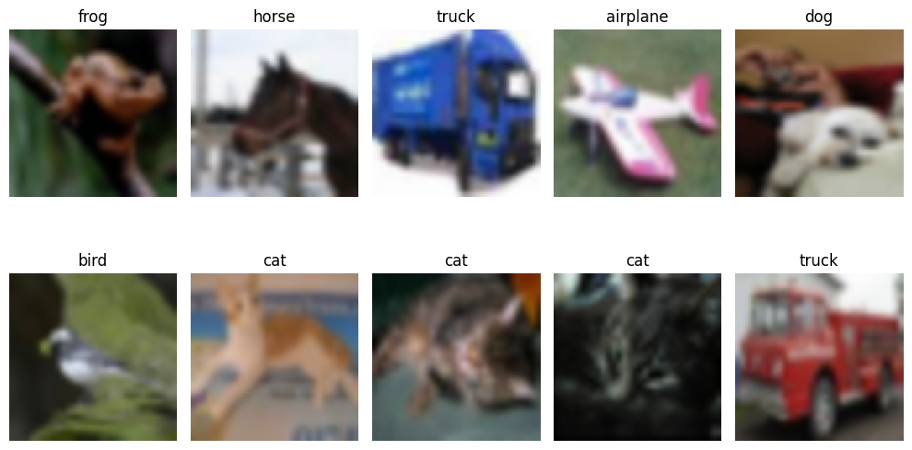

Model training and Evaluation:
Accuracy vs Epoch:
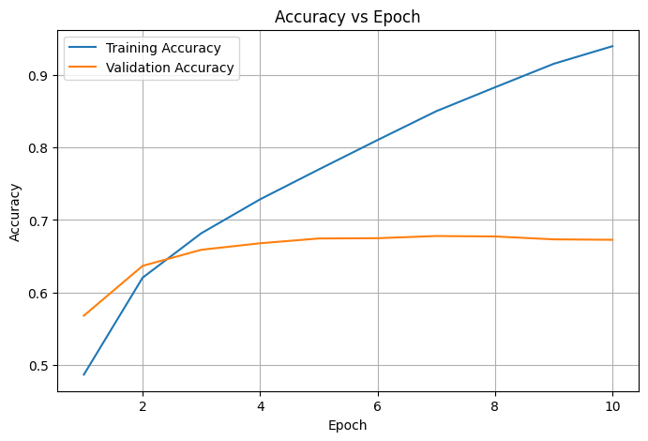
Loss vs Epoch:
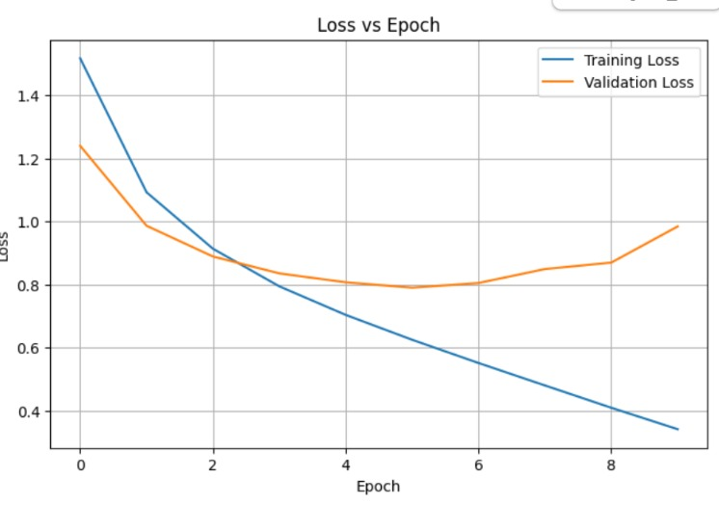

Performance Analysis:
Confusion Matrix - CIFAR-10 CNN
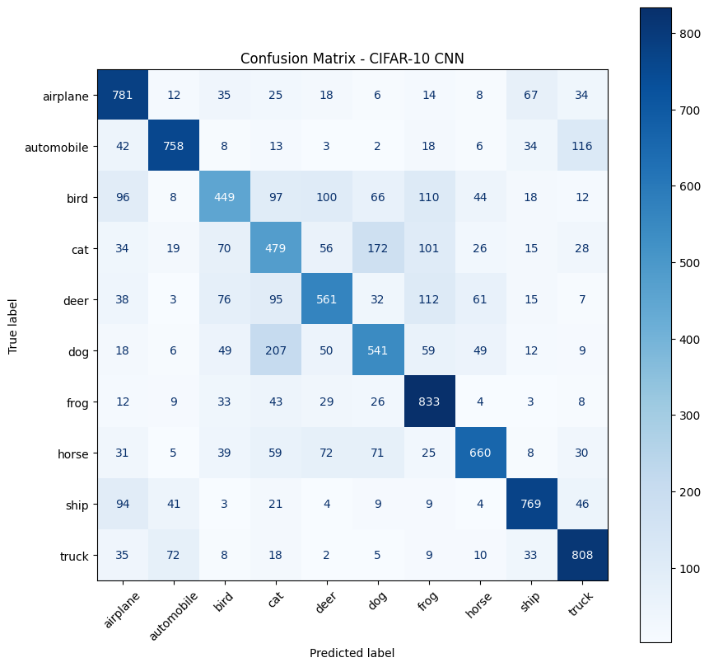
Actual vs Predicted (correct prediction):
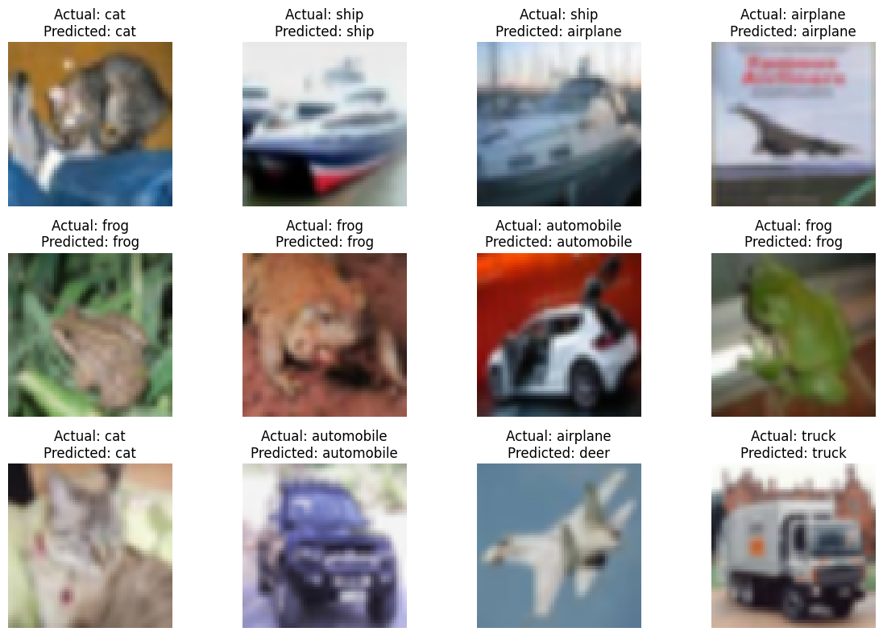
Actual vs Predicted (wrong prediction):
